Invitation to the 9th International Conference on Isotopes

Dear Colleagues,

It gives us pleasure to invite the international isotope community to the 9th International Conference on Isotopes (9ICI) to be held in Doha, Qatar, from 12 to 16 November 2017.

We expect to have more than 300 scientific and technical presentations and posters. The conference will provide a platform for isotope producers, users, decision makers, researchers and other role-players in isotope technology and applications to interact and discuss the latest developments in the field.

Please see details on www.9ici.org, and consider presenting a paper or poster on your work. There will also be an accompanying exhibition, showcasing organisations involved in isotope production, supply of equipment and various related topics.

This is going to be the first time for a conference in the ICI series will take place in the Middle East. Doha; the capital of Qatar, is a modern city that has a lot to offer from history, culture and seaside relaxation to high tech and a glorious skyline.

Special events during 9ICI will include medical physics and women in nuclear, the latter with a special session celebrating the birth of Marie Curie 150 years ago.

We look forward to welcoming you in Qatar in November 2017!

Sincerely,
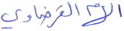
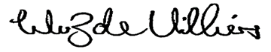
Van Zyl de Villiers Ilham Al-Qaradawi
PRESIDENT: WCI General Chair: 9ICI

